Instructions for 2018 NHS Sponsored Project:
SMHS Food Pantry “Toiletries Drive”
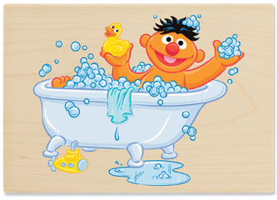
Students may turn in collected items for a maximum of 2 NHS sponsored service hours with this project. This year South Meck is collecting Non-Perishable Foods and Toiletry Items for South Meck students through an on-going Food Pantry. Many times people think of canned and boxed food but they don’t often consider that toiletries (hygiene products) are often overlooked but necessary purchases that might be challenging for some.
Students may drop off donated items to A204 before school (only with prior approval) between 6:50-7:00 but not after the 7:00 bell rings or after school. Donated items may be turned in from Monday, 12/10/18 through Friday, 12/14/18. Do not interrupt Mrs. Duke’s classes to turn in items.
All items must be full size (NO TRAVEL SIZE ITEMS WILL BE ACCEPTED)
All items must be individually wrapped (NO ONE WANTS A LOOSE TOOTHBRUSH/THINK ABOUT IT)
******Going to a Dollar Store is a good idea for getting multiple items that are individually packaged.
Only donate the following items:
Bars of Soap 6 bars= 1 service hour
Tubes of Toothpaste 6 tubes=1 service hour
Toothbrushes 6 toothbrushes=1 service hour
Bottles of Shampoo/Conditioner 6 bottles (either/or combined)=1 service hour
Deodorant 6 cans/sticks=1 service hour
Feminine Hygiene Products 2 packages of pads or tampons (12 or more in a package)

